Value Stream Mapping

Aim: Create a picture of the system of processes from beginning to end. Improve the “value Added” process through step-by-step review and identification of connections, activities, information, and flow.
What is a value-stream map?
A hands-on tool to show workflow, information flow, and value using process cycle time and first time quality metrics of % complete and % accurate.
Provides a system perspective to increase value and eliminate waste.
COMPLETE THIS PROCESS WITH AN INTERDISCIPLINARY TEAM
CLOSEST TO THE PROCESS
Interdisciplinary Team Members
1. Clarify process to improve
We aim to improve the process of
Beginning
of process
End of process
Checklist:
- Clarify Aim
- Create High Level Flowchart of process
- Add information and data flows
- Identify customer and supplies hand-offs
- Perform observational walk
  - Note customer/supplier,
  - Measure time of each step and total cycle time of process
- Determine delivery and quality requirements
- Design LEAN/improved process
Value Stream Map Examples
High Level Flow Chart Example
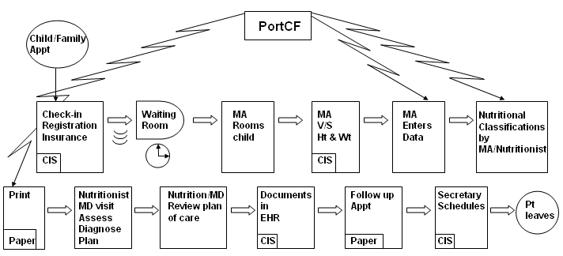

Deployment Flow Chart Example
© 2005 Godfrey 3/18/05

CIS

CIS

Paper
CIS
CIS
CIS
LAB
LAB

CIS

CIS

CIS

Paper

2. Make a High level flowchart of the process. Include all steps required to deliver a service or product. Focus on the CURRENT process of how work is done. A second option is to create a deployment flowchart which clarifies roles and functions.
Process Box
IN
“In” Box (Queue)
Symbol Key:
Begin or End Process
Activity step
Decision points
Waits and delays
Process flow direction
Unclear
Technology used
Wait Time
Verbal Information Flow
Electronic Information Flow
Rework
Material Movement
3. Identify and note customers and suppliers connections for each step in diagram.
What is the customer’s need?
Who supplies what to whom?
How does each customer make a request?
How does each supplier respond?
How does a supplier do his/her other work?
What problems exist and what problems are solved? By whom, when, where, and how?
4. Describe delivery and quality requirements. Determine key quality indicators.
5. Perform a value-stream waste “observational walk” through the process steps:
□ Follow movement of patient or product
□ Note information flow (paper, verbal, electronic)
□ Note inventory
□ Identify how work is “triggered” in the value stream
□ Identify how each step knows what to do next (sequencing)
□ Calculate process time, wait time, and 1st time quality for process steps and the entire value-stream “cycle” (% complete, % accurate, # defect free)
Current State Metrics | Current | Target
Process Time (cycle time)
Wait Time
First Time Quality
% Accurate
% Complete
# of Defects in Process
Create the Future State
  - Use Lean Principles and 4 Rules for Design to design an improved flow and process based on the waste you have identified.
Lean Principles
Do work on time
Identify problems before it’s too late
Eliminate waste
Reduce reproduction
Smooth workloads with standardized processes
  - What are the customer requirements?
  - Where and how will you trigger or sequence work?
  - How will you make work flow smoothly? (Reduce interruptions due to handoffs, delays, queue or rework)
  - How will work progress or delays and problems be evident? What will you measure? Who will measure?

4 Rules for Design
- All work must be highly specified as to content, sequence, timing, location and expected outcome
- Every customer-supplier connection must be highly specified, direct and there must be an unambiguous yes-or-no way to send requests and receive responses
- The pathway for every product and service must be predefined, highly specified, simple, and direct with no loops or forking
- Any improvement must be made in accordance with the scientific method, under the guidance of a teacher, by those closest to the work towards the ideal state.

© 2005 Godfrey 9/18/05

